The Homeless Advocacy Project & PECO
Present a Free:

Birth Certificate Clinic

When? Monday, November 3, 2014 9:00 a.m. - 11:00 a.m.

Where? PECO EXELON
2301 Market Street, (Energy Hall A & B)
Philadelphia, PA 19101

Who? Open (and free of charge) to homeless individuals and families and those at risk of
homelessness

Birth certificates are often needed to receive medical assistance, housing and other public benefits, to obtain a Pennsylvania driver’s or non-driver’s license, for access to many public buildings, for general identification and for many other purposes.

Homeless individuals who attend this free clinic will meet with an advocate who will request birth certificates for them and their minor children free of charge.

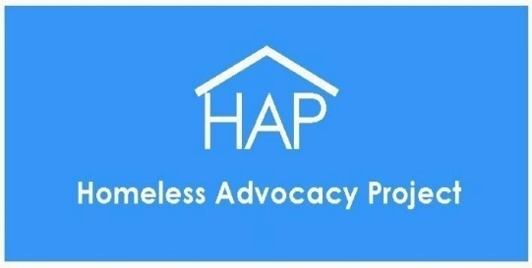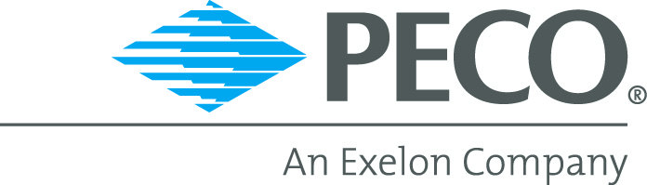

For additional information, please contact Homeless Advocacy Project at 215-523-9595
Or visit us at www.homelessadvocacyproject.org

