Join us to remember
Hyacinth King
(1950 - 2017)
Beloved Activist, Trustee and Friend

Thursday, May 4
11 am
1515 Fairmount Avenue
Project HOME Backspace

Lunch will be served after the memorial.

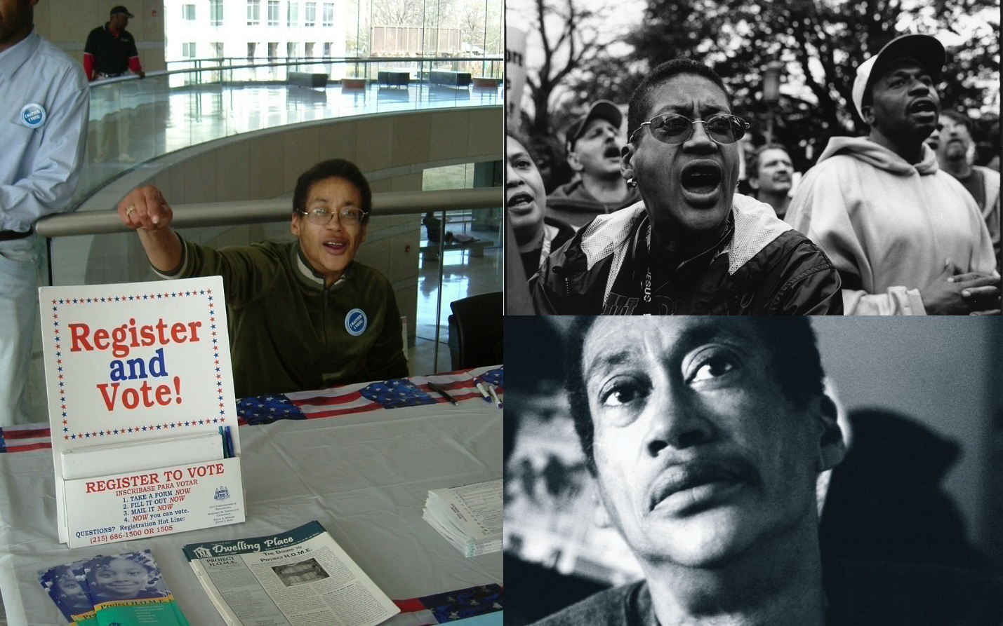

For more information, contact Will O’Brien (willobrien@projecthome.org) and Jennine Miller
(jenninemiller@projecthome.org) or 215-232-7272

